1.import pandas as pd

import numpy as np

import matplotlib.pyplot as plt

import seaborn as sns

2.dataset = pd.read_excel("2255872-anime_data.xlsx")

1. dataset.head(2)

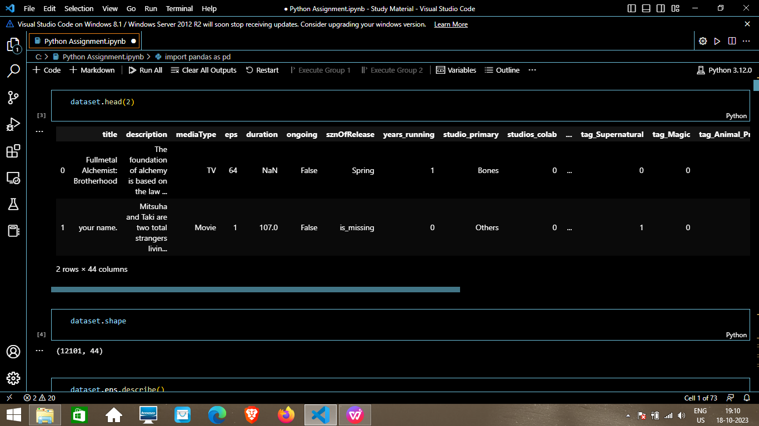

1. Dataset.shape

Ans.(12101, 44)

1. Dataset.eps.describe()

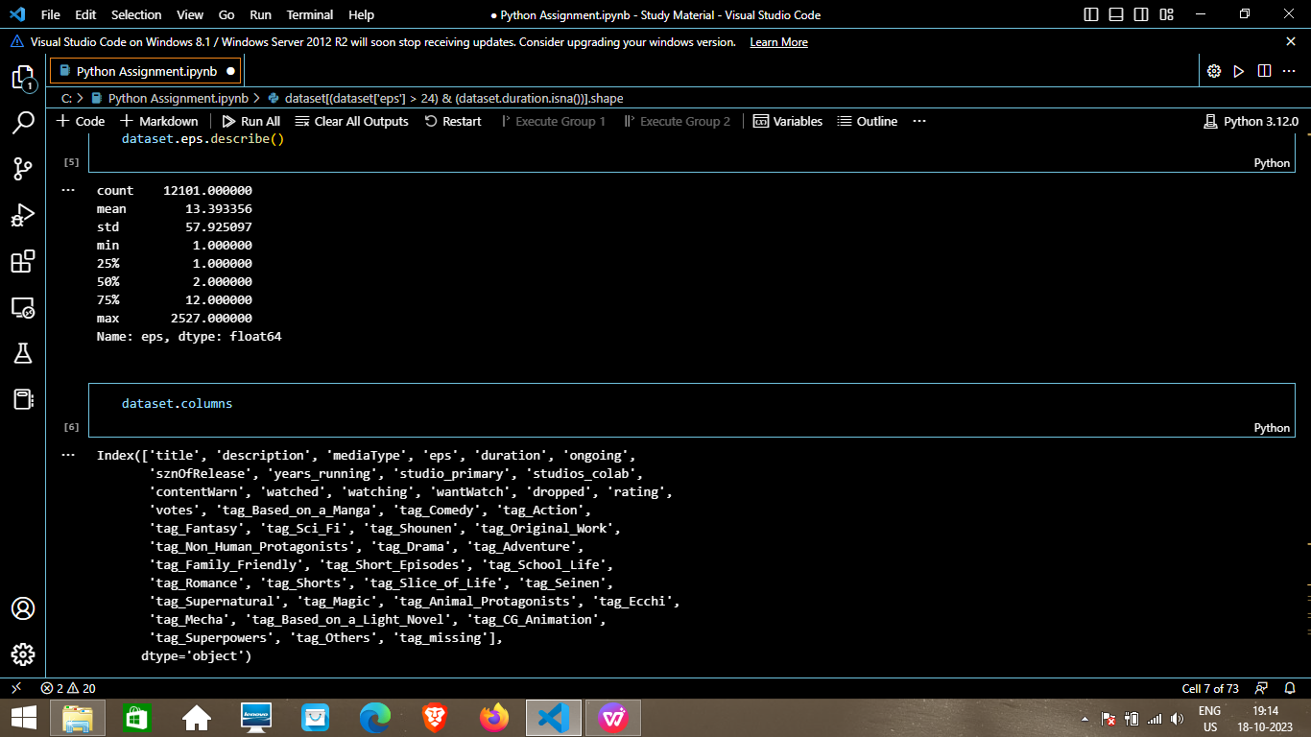

1. Dataset.columns



1. dataset[(dataset['eps'] > 24) & (dataset.duration.isna())].shape

Ans.(1493, 44)

1. dataset_excluding_out = dataset[dataset['eps'] < 50]
2. dataset_excluding_out['eps_brackets'] = pd.cut(dataset_excluding_out['eps'], bins = [1,10,20,30,40,50],\labels = ['cat1','cat2','cat3','cat4','cat5'])
3. dataset_excluding_out.shape

Ans.(11388, 45)

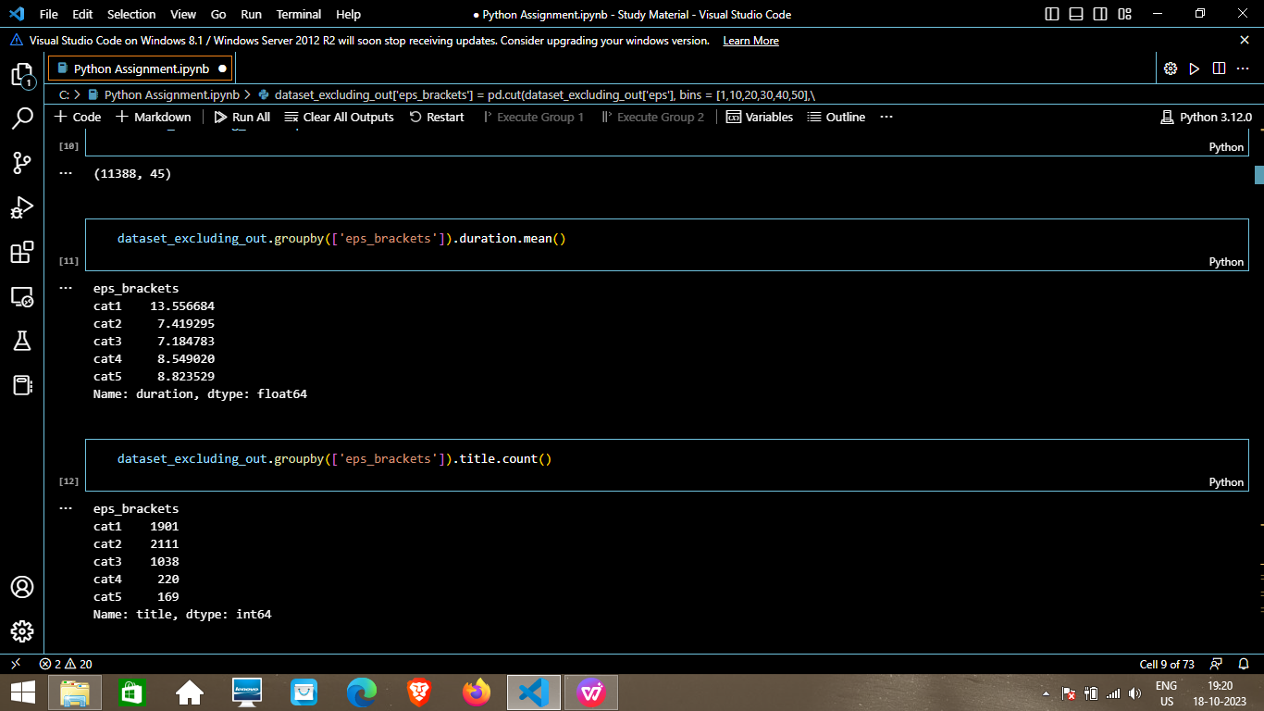

1. dataset_excluding_out.groupby(['eps_brackets']).duration.mean()



1. dataset_excluding_out.groupby(['eps_brackets']).title.count()



1. dataset_excluding_out[dataset_excluding_out['eps_brackets'] == 'cat1'].shape

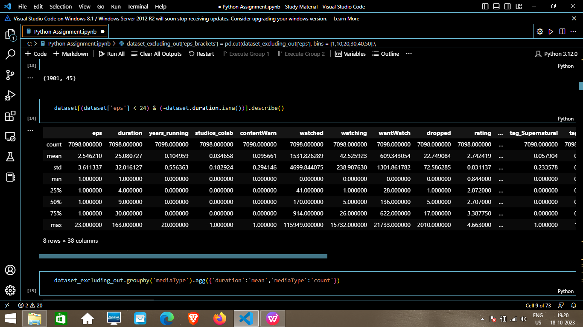

1. dataset[(dataset['eps'] < 24) & (~dataset.duration.isna())].describe()



1. dataset_excluding_out.groupby('mediaType').agg({'duration':'mean','mediaType':'count'})

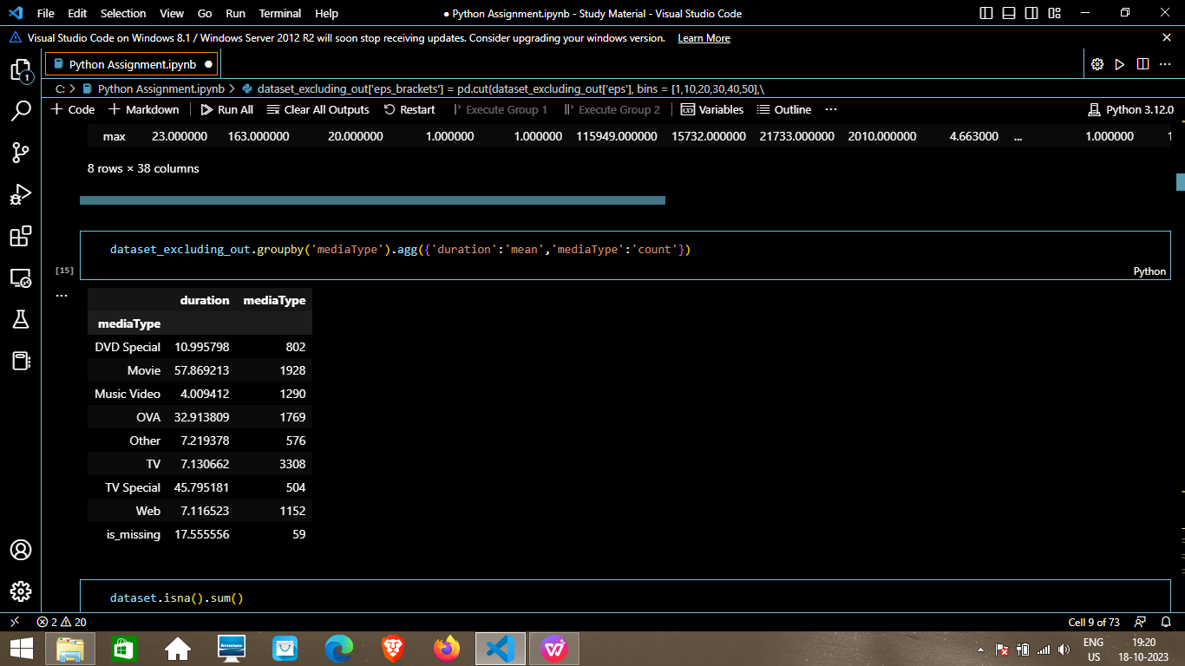

1. dataset.isna().sum()

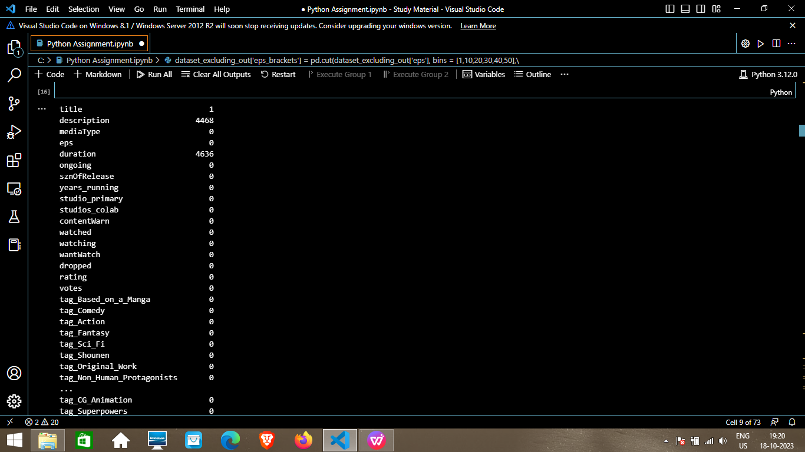

1. dataset.info()

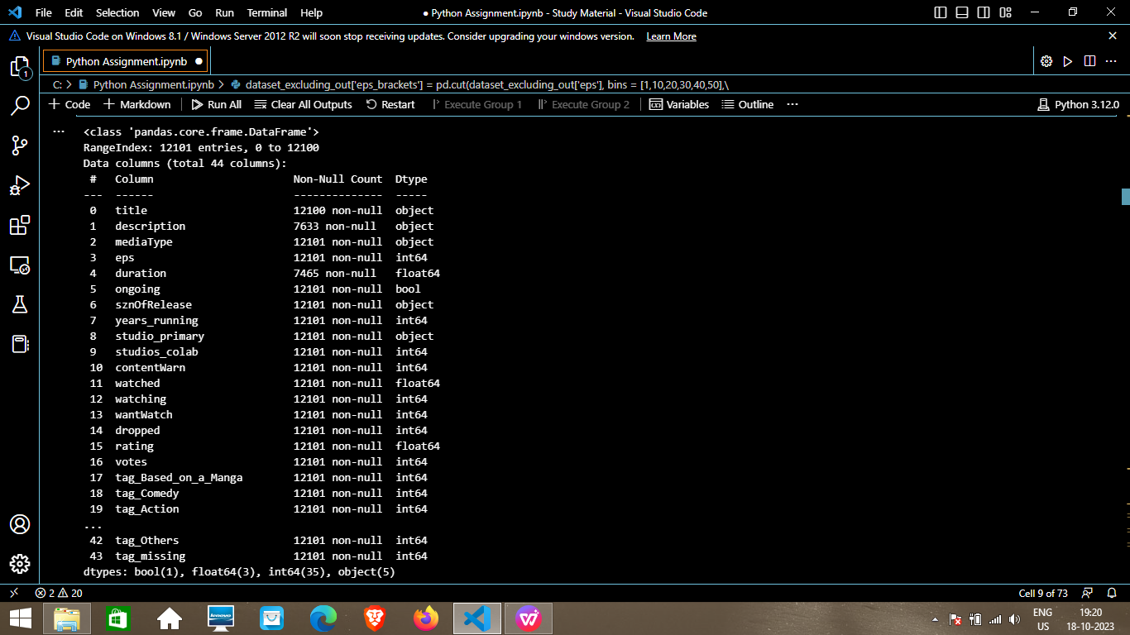

1. dataset.describe().T

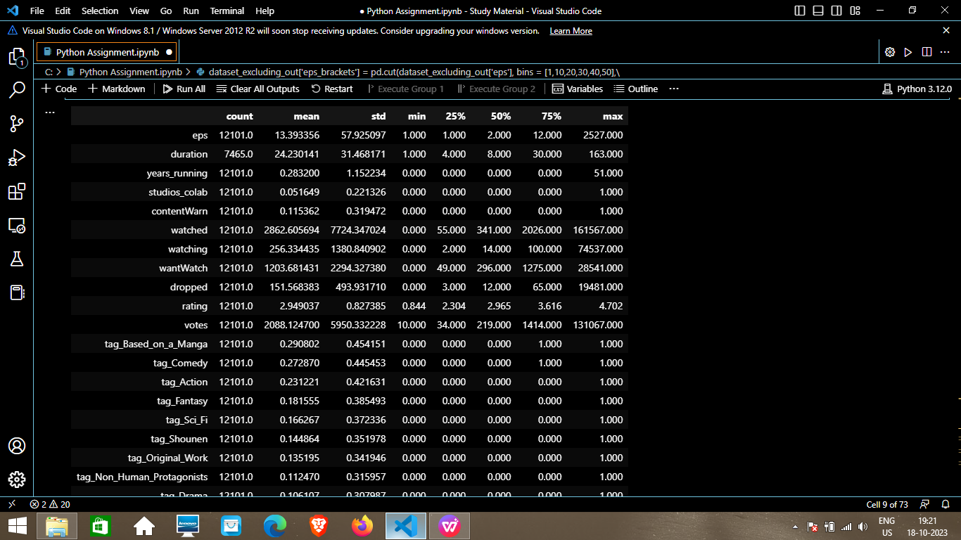

1. dataset.drop(columns = ['title','description'], axis=1, inplace=True)
2. dataset.head()

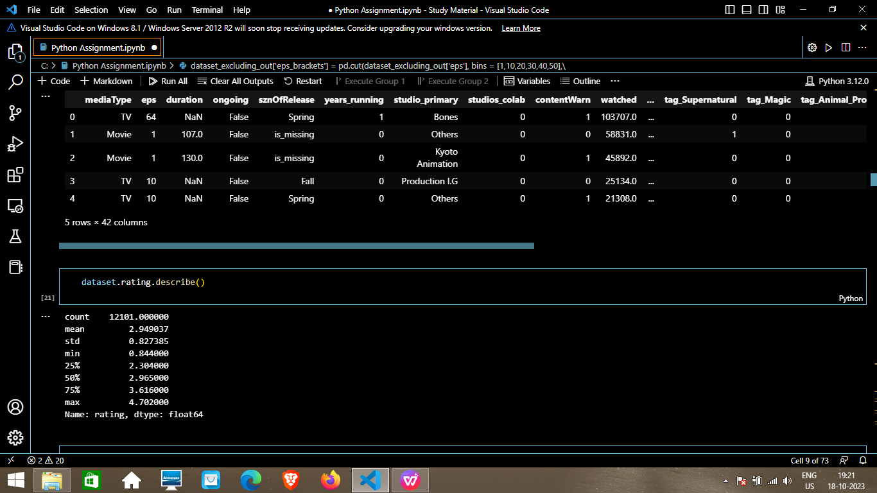

1. dataset.rating.describe()



1. dataset.dropna(inplace=True)

dataset.shape

Ans.(7465, 42)

23.def continuous_univariate_analysis(data,

feature,

figsize=(12,8),

kde=False,

bins=None):

f1, (ax_box,

ax_hist) = plt.subplots(nrows=2,

sharex=True,

gridspec_kw={'height_ratios': (0.25,0.75)},

figsize=figsize)

sns.color_palette("viridis", as_cmap=True)

sns.boxplot(data=data,

x=feature,

ax=ax_box,

showmeans=True,

color='yellow')

sns.histplot(data=data,

x=feature,

ax=ax_hist,

showmeans=True,

color='crest',

bins=bins,

kde=kde) if bins else sns.histplot(

data=data, x=feature, ax=ax_hist, kde=kde, color='blue')

ax_hist.axvline(data[feature].mean(), color='cyan', linestyle='--')

ax_hist.axvline(data[feature].median(), color='orange', linestyle="-")

24. def discrete_univariate_analysis(data, feature, perc=False, n=None):

total = len(data[feature])

count = data[feature].nunique()

if n is None:

plt.figure(figsize=(count + 1, 5))

else:

plt.figure(figsize=(n + 1, 5))

plt.xticks(rotation=90, fontsize=15)

ax = sns.countplot(

data=data,

x=feature,

palette="flare",

order=data[feature].value_counts().index[:n].sort_values(ascending=False))

for p in ax.patches:

if perc == True:

label = "{:.1f}%".format(100 * p.get_height() / total)

else:

label = p.get_height()

x = p.get_x() + p.get_width() / 2

y = p.get_height()

ax.annotate(label, (x, y),

ha="center",

va="center",

size=12,

xytext=(0, 5),

textcoords="offset points")

plt.show()

1. dataset.columns

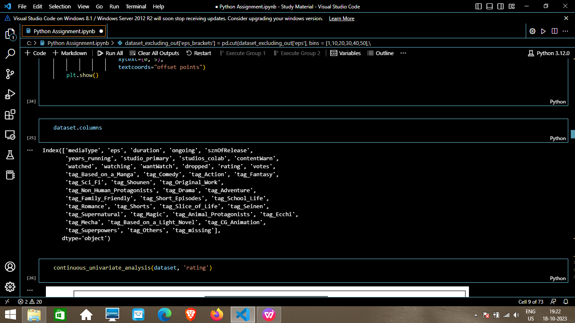

1. continuous_univariate_analysis(dataset, 'rating')

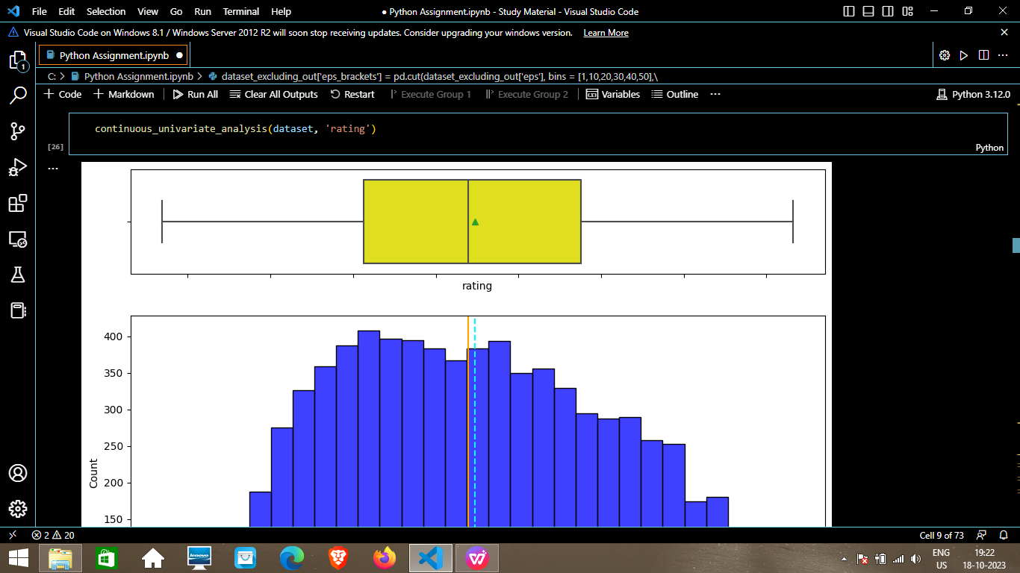

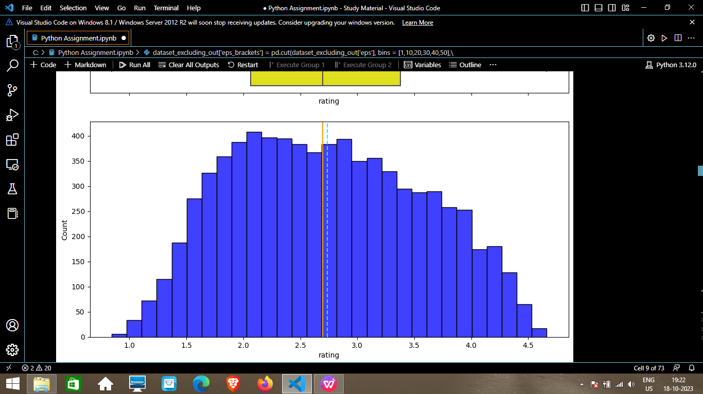

1. continuous_univariate_analysis(dataset, 'duration')

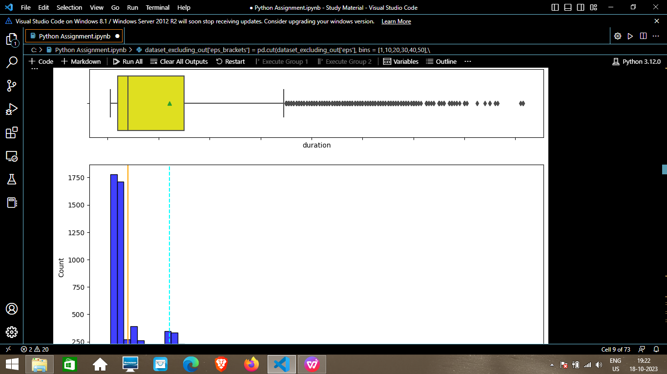

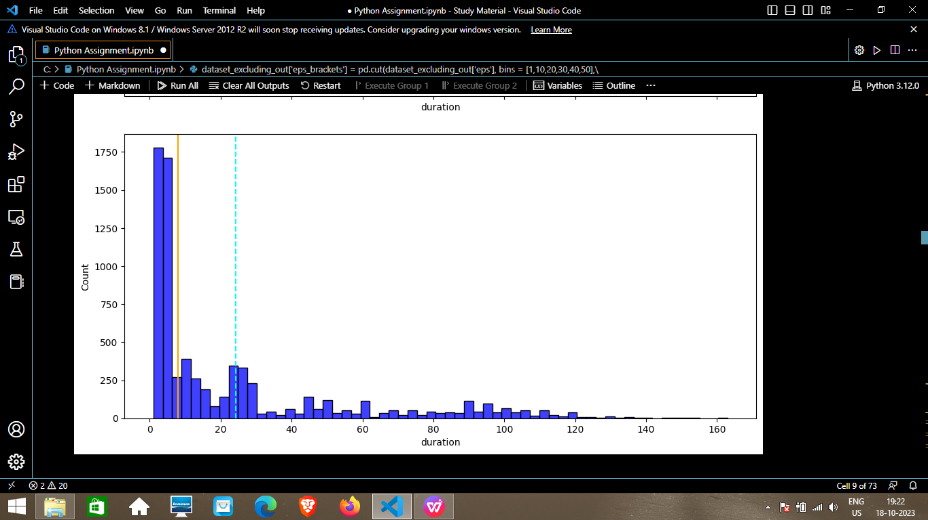

1. dataset[dataset['duration'] >=80]['rating'].mean()

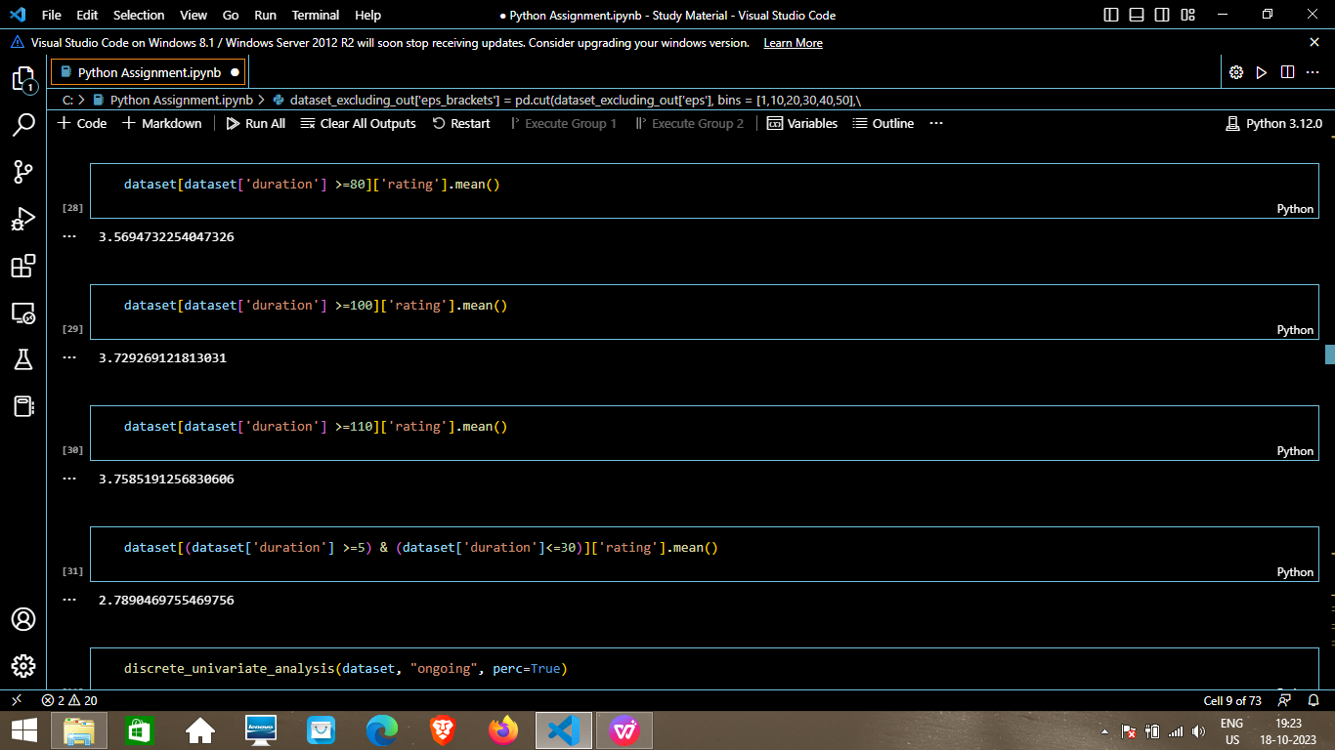

1. dataset[dataset['duration'] >=100]['rating'].mean()



1. dataset[dataset['duration'] >=110]['rating'].mean()



1. dataset[(dataset['duration'] >=5) & (dataset['duration']<=30)]['rating'].mean()



1. discrete_univariate_analysis(dataset, "ongoing", perc=True)

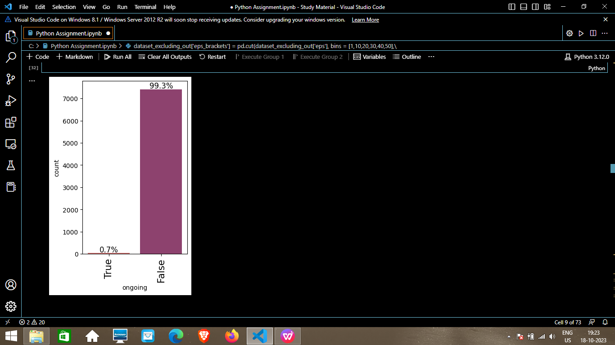

1. dataset[dataset['ongoing'] == True]['rating'].mean()

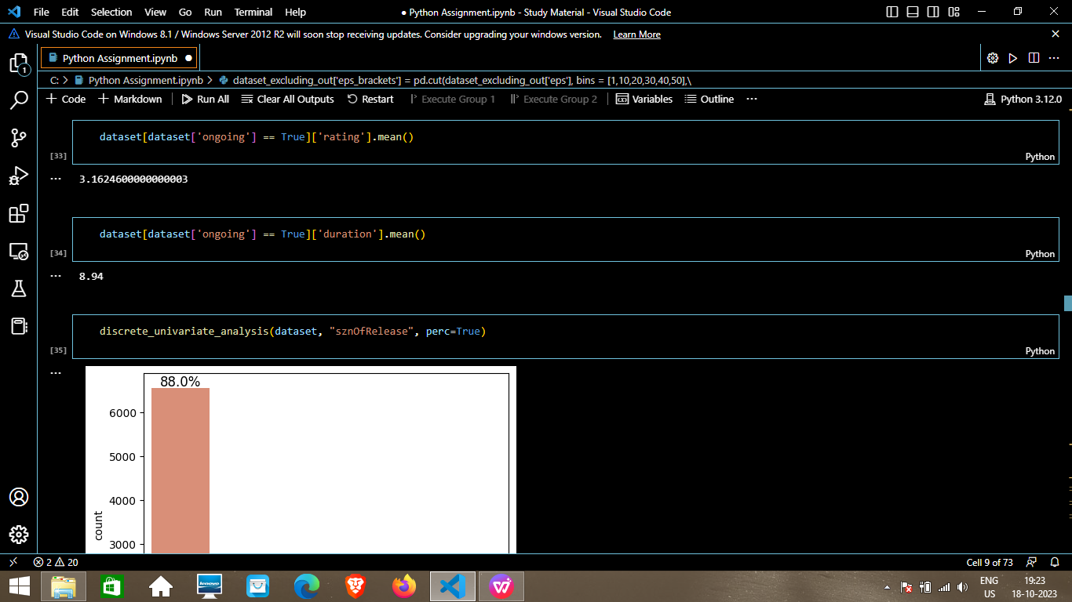

1. dataset[dataset['ongoing'] == True]['duration'].mean()



1. discrete_univariate_analysis(dataset, "sznOfRelease", perc=True)

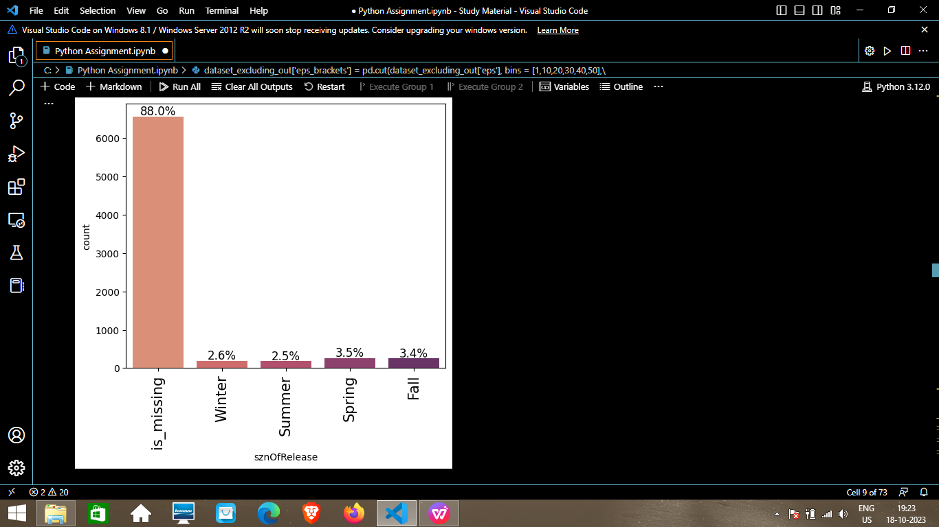

1. discrete_univariate_analysis(dataset , "studio_primary", perc=True)

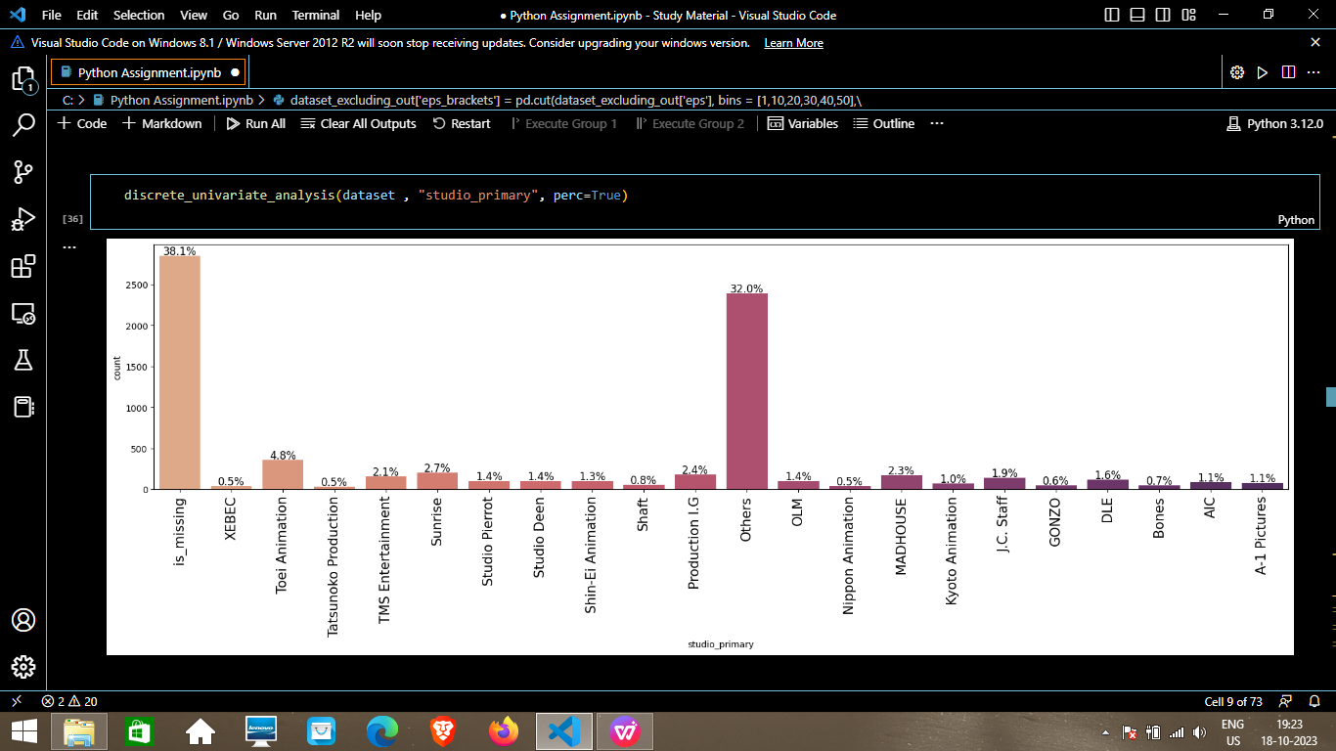

1. dataset[dataset['rating'] >4]

['studio_primary'].value_counts(normalize=True).mul(100).round(2)

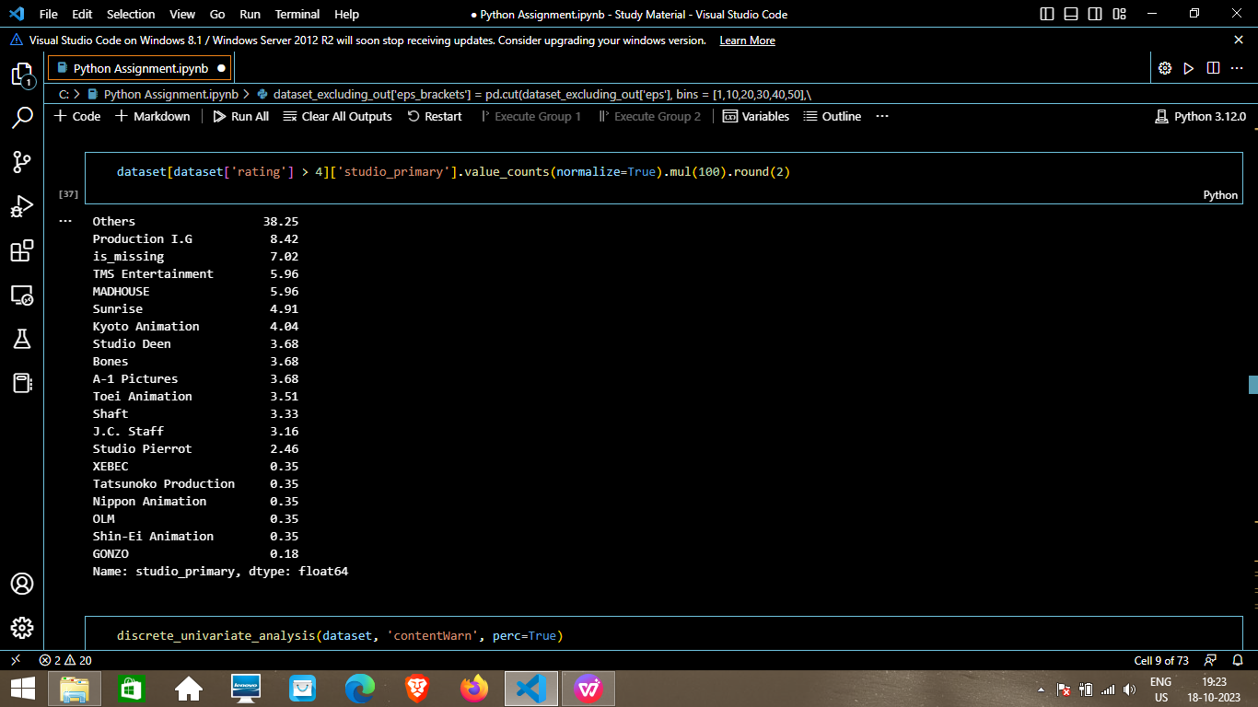

1. discrete_univariate_analysis(dataset, 'contentWarn', perc=True)

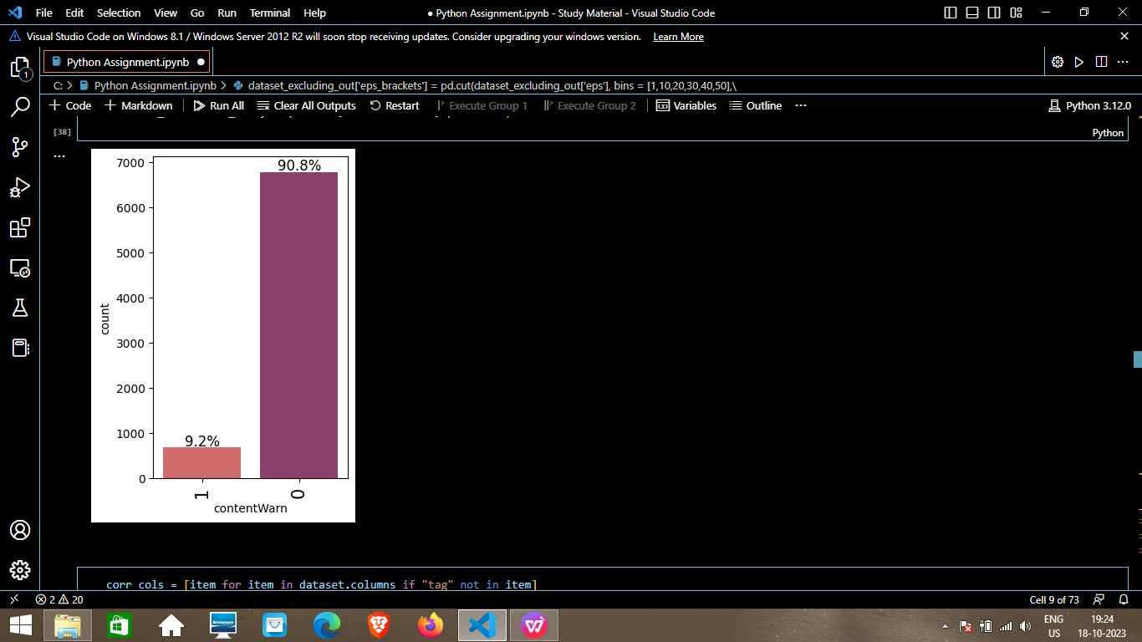

1. corr_cols = [item for item in dataset.columns if "tag" not in item]
2. corr_cols

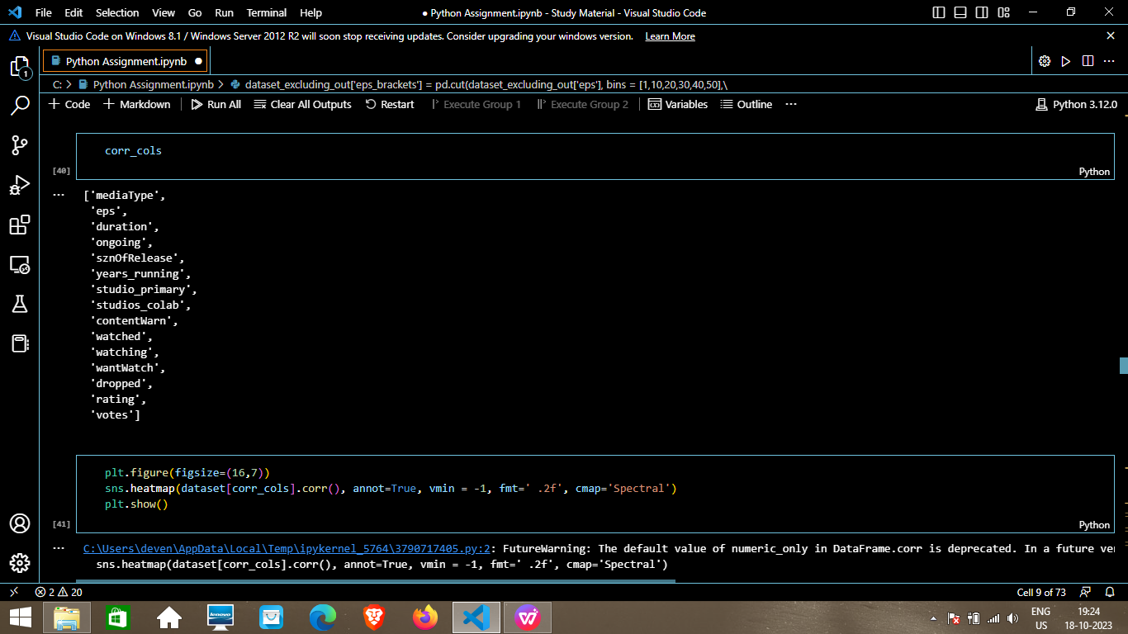

1. plt.figure(figsize=(16,7))

sns.heatmap(dataset[corr_cols].corr(), annot=True, vmin = -1, fmt=' .2f', cmap='Spectral')

plt.show()

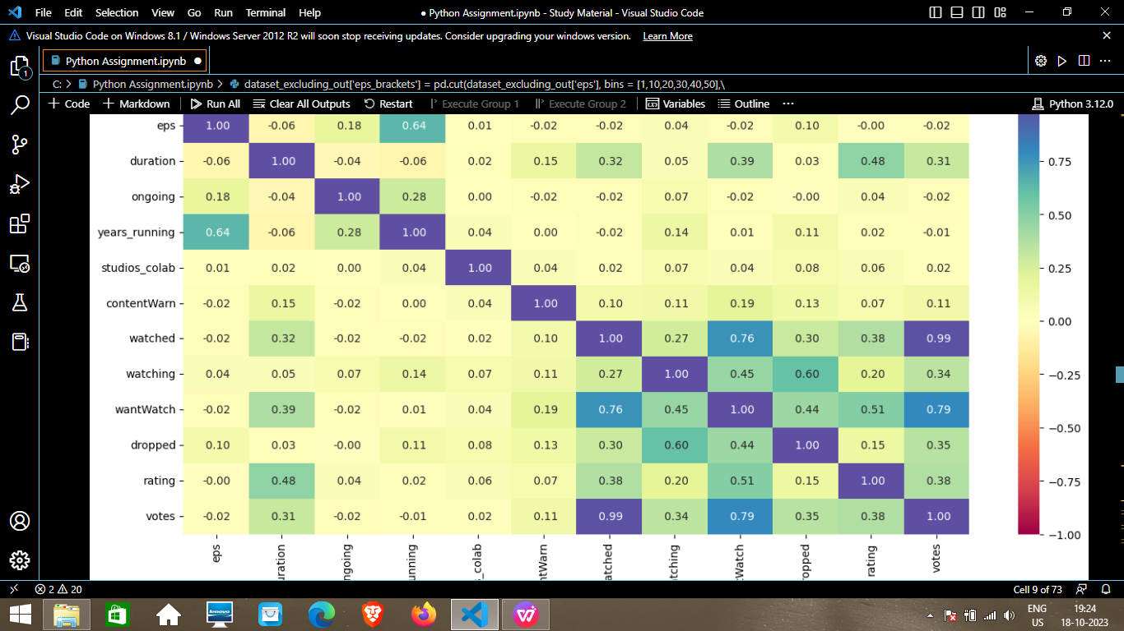

1. dataset.drop(columns= ['eps', 'watched'], inplace=True)
2. dataset.shape

Ans.(7465, 40)

1. plt.figure(figsize=(15,8))

sns.boxplot(x = 'sznOfRelease', y='rating', data=dataset)

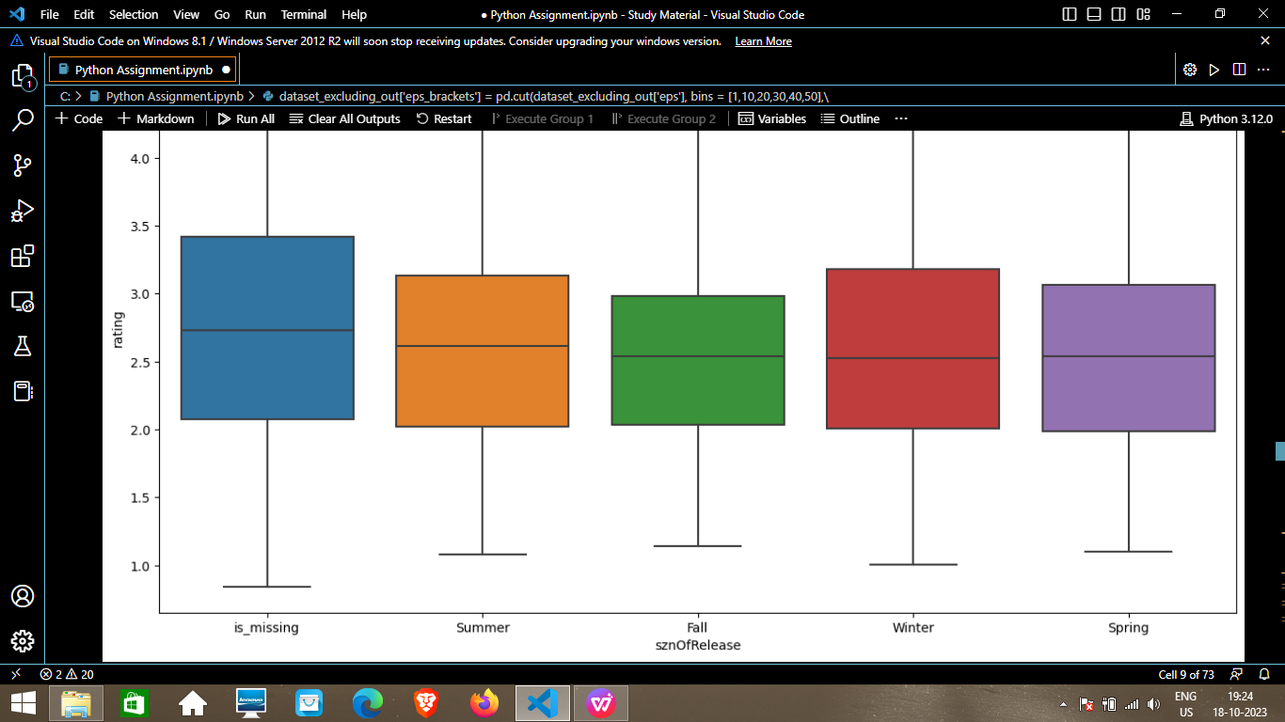

1. x = dataset.drop(['rating'], axis=1)

y = dataset['rating']

1. x = dataset.drop(['rating'], axis=1)

y = dataset['rating']

1. x.info()

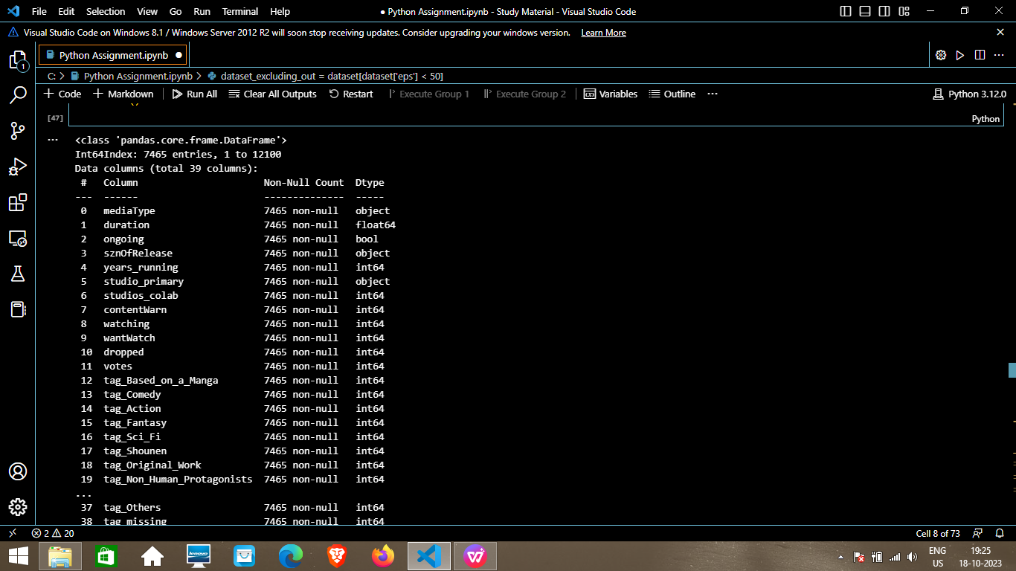

1. x = pd.get_dummies(x, columns=x.select_dtypes(include=['object', 'category']).columns.tolist(), drop_first=True)

x.head()

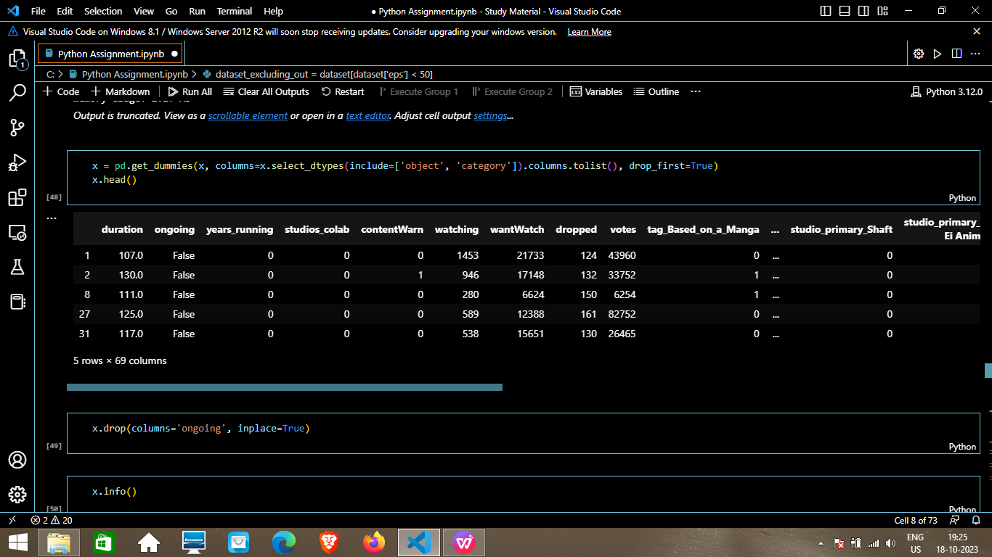

1. x.drop(columns='ongoing', inplace=True)
2. x.info()

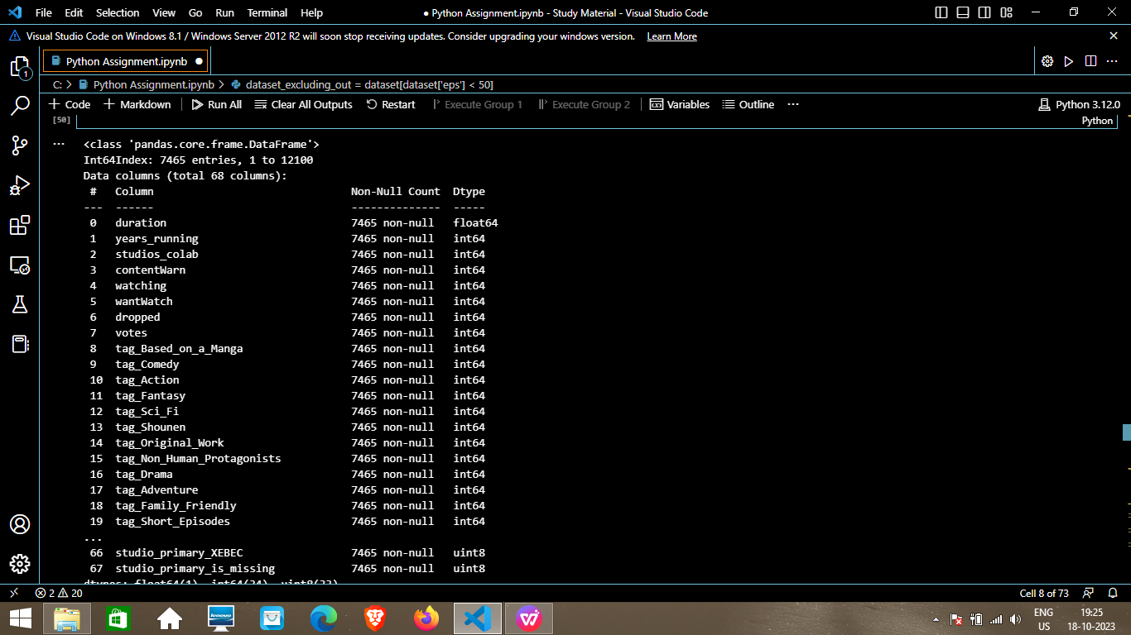

51. from sklearn.model_selection import train_test_split

from sklearn.linear_model import LinearRegression

from sklearn.metrics import mean_squared_error, r2_score, mean_absolute_error

1. X_train, X_test, Y_train, Y_test = train_test_split(x,y, test_size=0.2, random_state=1)
2. print("Number of samples for train", X_train.shape[0])

print("Number of samples for test", X_test.shape[0])

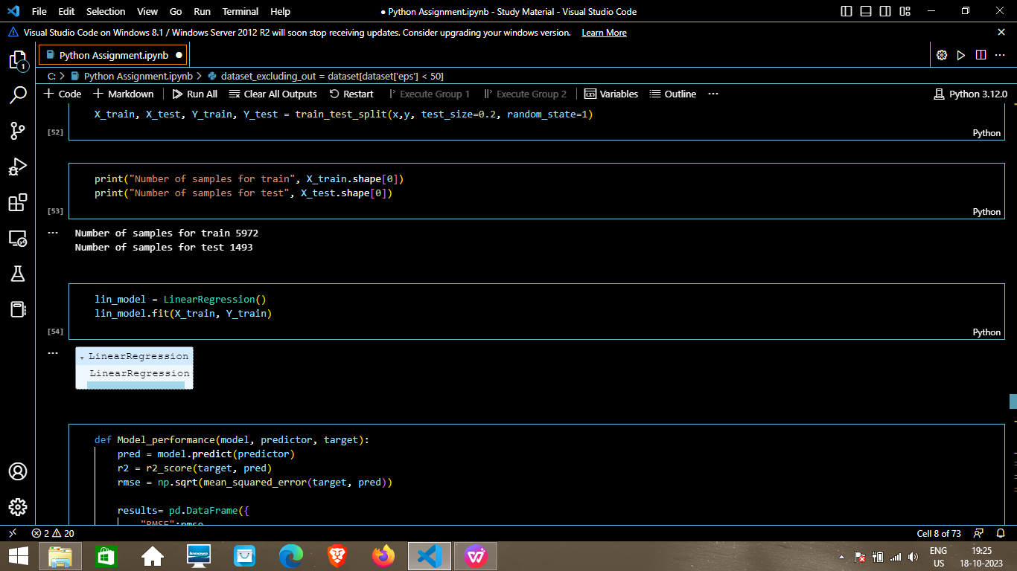

1. lin_model = LinearRegression()

lin_model.fit(X_train, Y_train)



1. def Model_performance(model, predictor, target):

pred = model.predict(predictor)

r2 = r2_score(target, pred)

rmse = np.sqrt(mean_squared_error(target, pred))

results= pd.DataFrame({

"RMSE":rmse,

"R2 Score":r2

}, index=[0]

)

return results

1. print("Training Data Performance")

lin_model_train = Model_performance(lin_model, X_train, Y_train)

lin_model_train

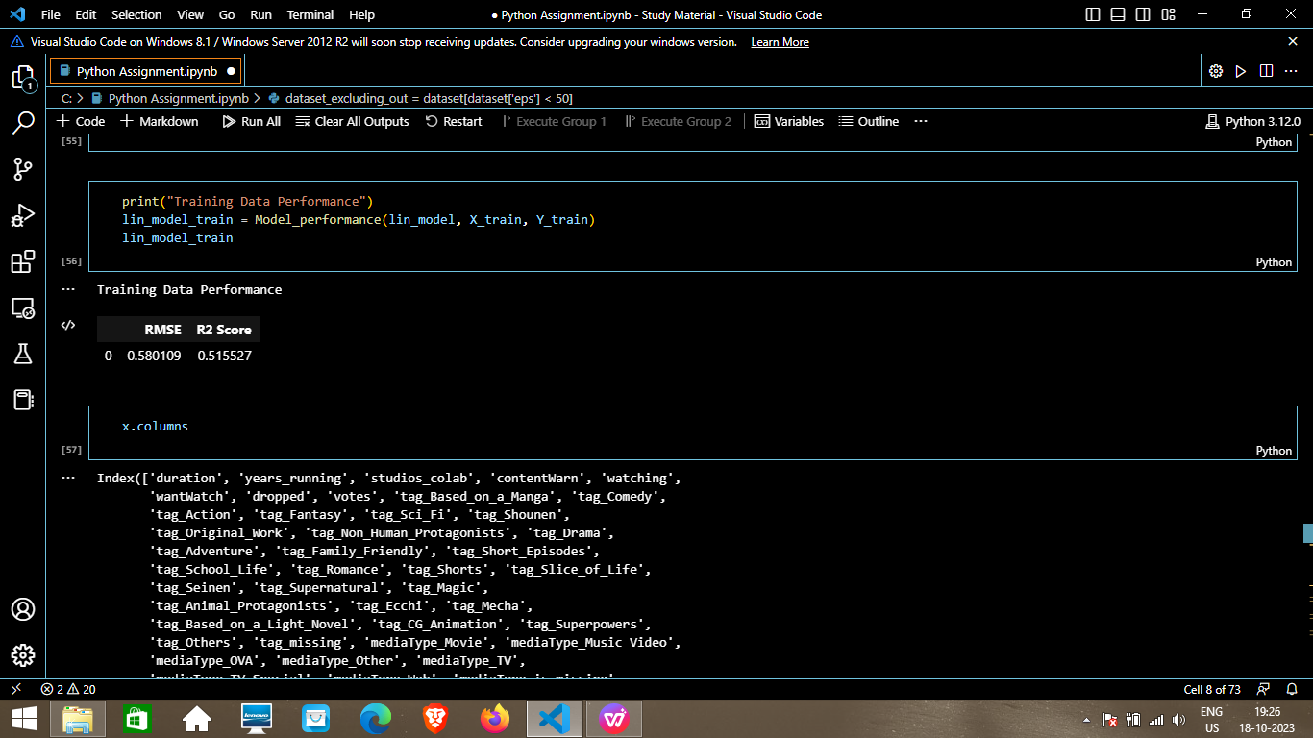

1. x.columns

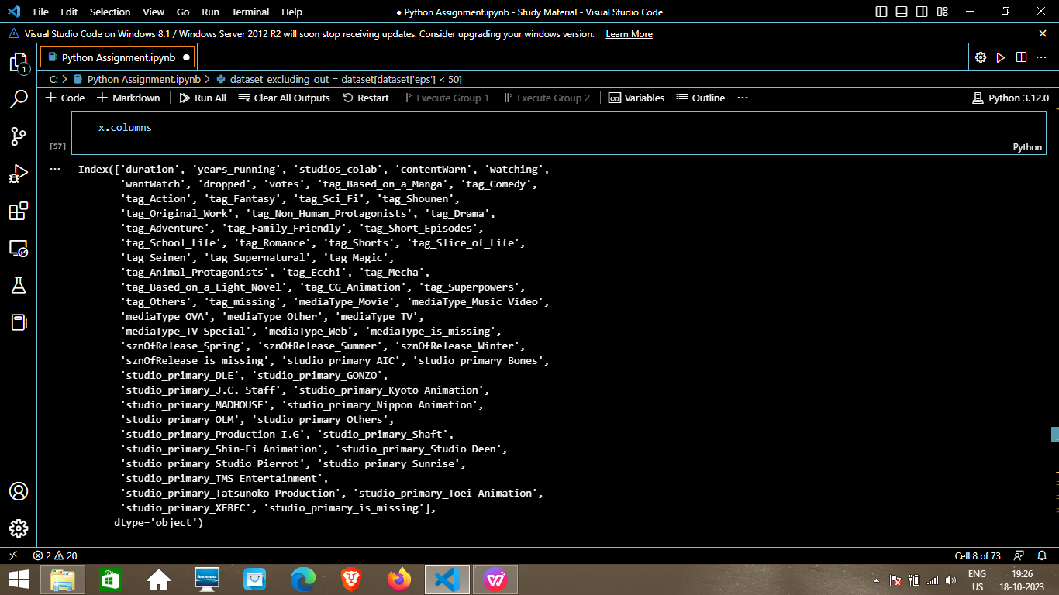

1. conda install mlxtend

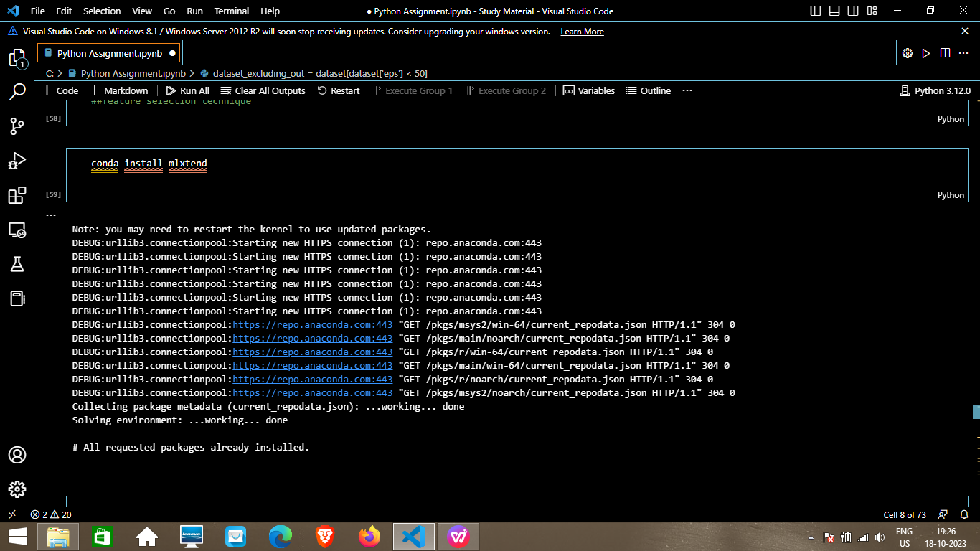

1. from mlxtend.feature_selection import SequentialFeatureSelector as SFS

reg = LinearRegression()

sfs = SFS(reg, k_features = X_train.shape[1],

forward = True, floating=False, scoring='r2', n_jobs= -1, cv=5)

sfs = sfs.fit(X_train, Y_train)

1. from mlxtend.plotting import plot_sequential_feature_selection as plot_sfs

fig1 = plot_sfs(sfs.get_metric_dict(), kind='std_err', figsize=(15,5))

plt.title("Feature Selector - SFS")

plt.xticks(rotation=90)

plt.show()

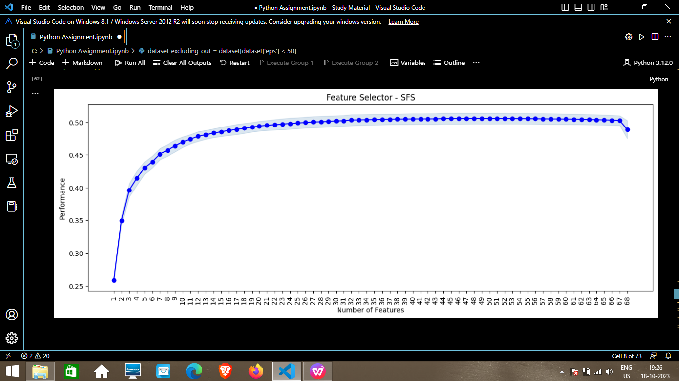

1. from mlxtend.feature_selection import SequentialFeatureSelector as SFS

reg = LinearRegression()

sfs = SFS(reg, k_features = 30,

forward = True, floating=False, scoring='r2', n_jobs= -1, cv=5)

sfs = sfs.fit(X_train, Y_train)

1. from mlxtend.plotting import plot_sequential_feature_selection as plot_sfs

fig1 = plot_sfs(sfs.get_metric_dict(), kind='std_err', figsize=(15,5))

plt.title("Feature Selector - SFS")

plt.xticks(rotation=90)

plt.show()

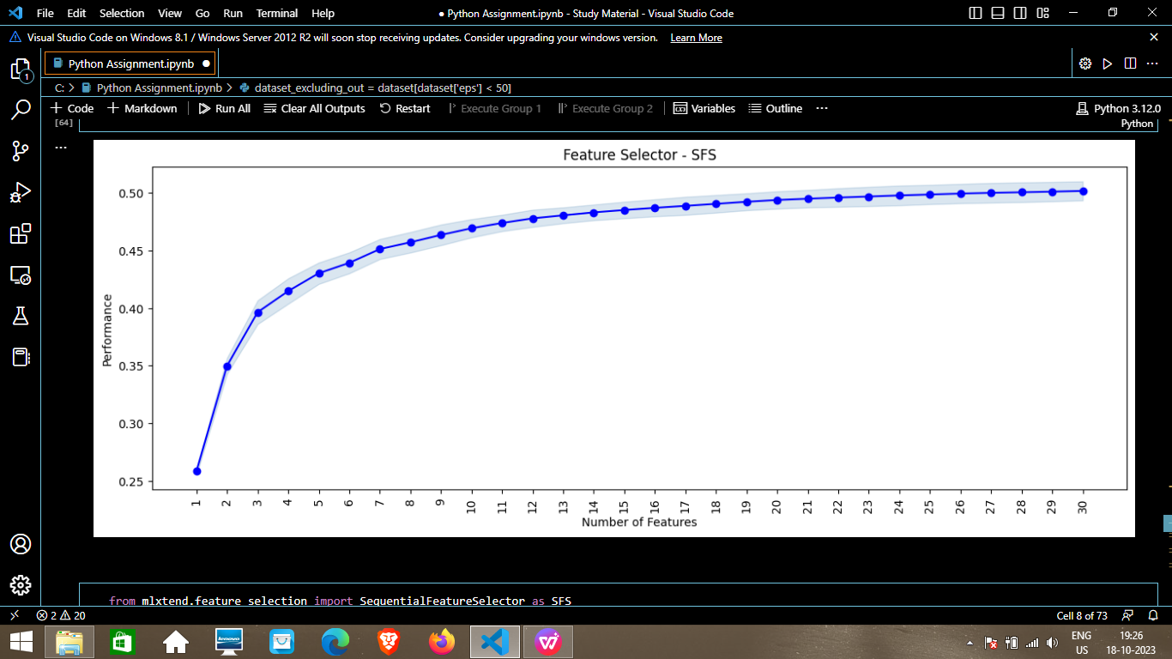

1. from mlxtend.feature_selection import SequentialFeatureSelector as SFS

reg = LinearRegression()

sfs = SFS(reg, k_features = 35,

forward = True, floating=False, scoring='r2', n_jobs= -1, cv=5)

sfs = sfs.fit(X_train, Y_train)

1. from mlxtend.plotting import plot_sequential_feature_selection as plot_sfs

fig1 = plot_sfs(sfs.get_metric_dict(), kind='std_err', figsize=(15,5))

plt.title("Feature Selector - SFS")

plt.xticks(rotation=90)

plt.show()

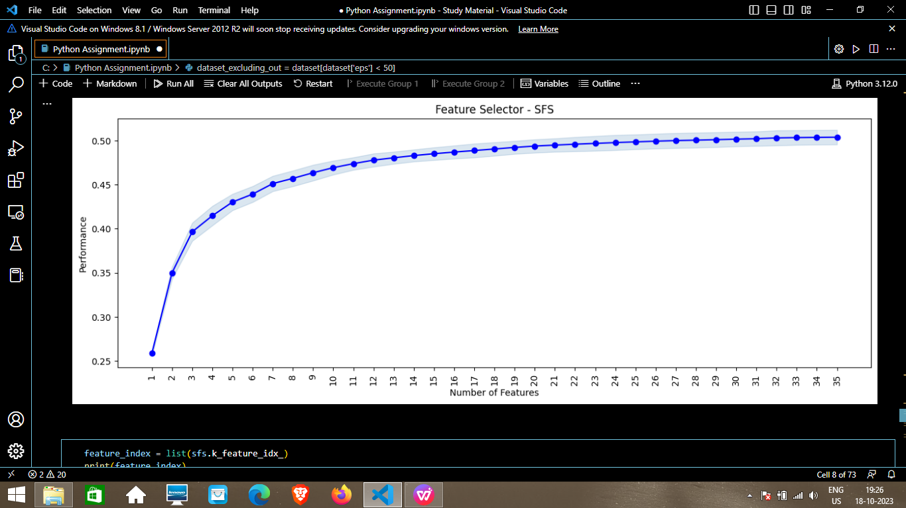

1. feature_index = list(sfs.k_feature_idx_)

print(feature_index)

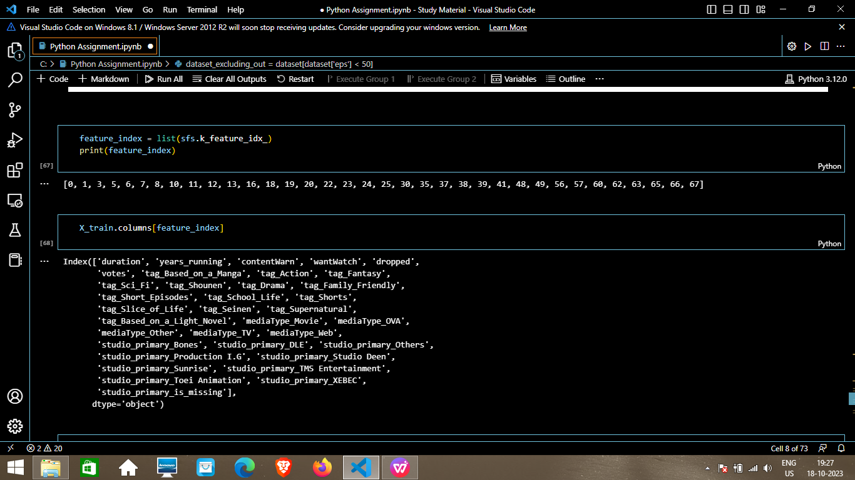

1. X_train.columns[feature_index]



1. X_train_final = X_train[X_train.columns[feature_index]]

X_test_final = X_test[X_test.columns[feature_index]]

1. lin_model_v2 = LinearRegression()

lin_model_v2.fit(X_train_final, Y_train)

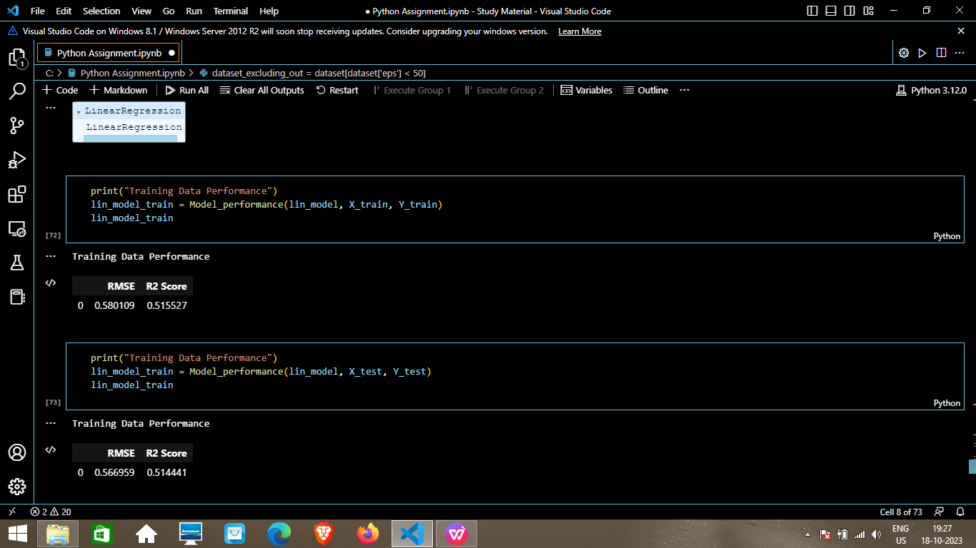

69.print("Training Data Performance")

lin_model_train = Model_performance(lin_model, X_train, Y_train)

lin_model_train



70.print("Training Data Performance")

lin_model_train = Model_performance(lin_model, X_test, Y_test)

lin_model_train



1. X_train.columns[feature_index]

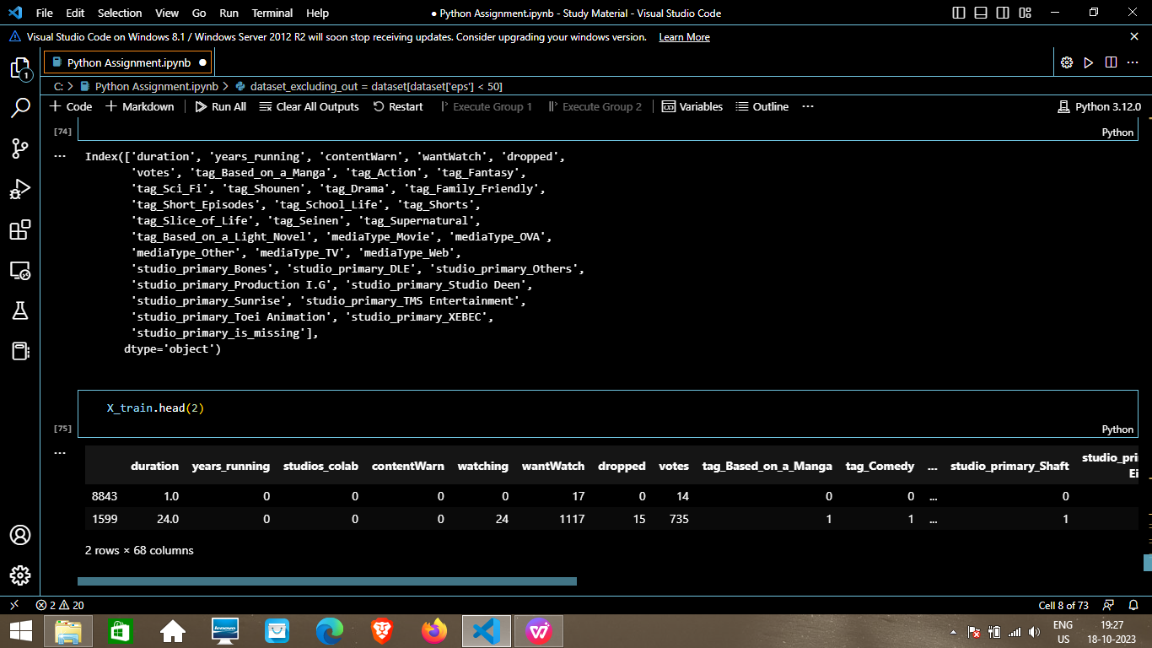

1. X_train.head(2)

